Using Powys Templates In MapInfo

The following is a guide for using the new Powys templates, which will be replacing the old Exegesis templates in MapInfo.

When you open MapInfo you should see this toolbar:

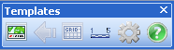

If not, go to Tools > Tool Manager and tick the Loaded and Autoload boxes next to “*PowysTemplates”. Click OK and the Templates toolbar should now appear.

As long as you have a map window open, you can create a template for printing your map out. Click on the “Create Print Template” button and the following dialogue box will appear:

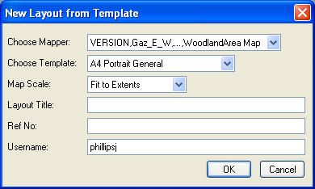

Choose Mapper: This allows you to select which map window you want to put into a template, if you have more than one map window open. The default is the first map window opened, but a different one can be selected from the drop down list.

Choose Template: This allows you to select what type of template you want to put your map in, e.g. A4 Portrait.

Map Scale: This allows you to set the scale of the map window in the template. You can either select a specific scale, e.g. 1:1250, or choose one of the following options:
- Fit to Extents – this is selected by default, and does the same as the Fit button option in the old templates. The map window is automatically sized to fit within the frame of the template, and is centred within this frame. For example, if the map viewed on the screen is wider than it is long but a portrait print-out is required, the template will centre the map shown within the portrait frame and show more of the “top” and “bottom” parts of the specified map on the layout.
- Keep Current Scale – this option keeps the current scale of the map window. Beware, if your map window is a different shape to the map window on the template you will lose part of the map view with this option.

Layout Title: Allows you to add a title for your template (not needed on bare minimum templates).

Ref No: Allows you to add an optional reference number for your template (not needed on bare minimum templates).

Username: This automatically gets filled with the username you logged in with, but can be changed if needs be.

The template will be created and the templates toolbar should now look like this, with the create template (green) button greyed out and the other buttons activated:

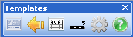

Additional template options

Close template – use this button to return to the map window after you have printed your map out. This returns you to the point just before the template was created.

Adding/removing a grid - this button allows you to toggle a grid on/off on the main map window in the template. This will automatically update if you move the map. You can change grid options using the options button .

Adding/removing a scalebar - this button allows you to toggle a scalebar on/off on the main map window in the template. This will automatically update if you move the map. You can change scalebar options using the options button .

Options – This button gives you options for changing the way grids and scalebars are viewed on the template. The following options are given:

Grid Options
- Grid Lines On/Off – tick this box if you want gridlines, as well as labels, over the map window. If this is unchecked, just labels and tick marks will be displayed around the edge of the map frame.
- Grid Label Format – choose how you want the grid labels to be displayed around the edge of the map frame. Full Grid References are the full 12 figure grid reference (6 figure easting and 6 figure northing), OS Style References are the 4 figure grid references found on some of the Ordnance Survey maps, and Definitive Map Style are the 10 figure grid references found on the Definitive Rights of Way maps.
- Line Style – this allows you to change the style of the gridlines.
- Label Style - this allows you to change the style of the grid labels.

Scalebar Options
- Scalebar Position – this determines whether the scalebar will be placed in the bottom left or bottom right of the map frame.
- Scalebar Units – allows you to choose whether the units of the scalebar are shown in metric or imperial.
- Scalebar Style - allows you to choose whether the scalebar is shown as a tick-bar or solid block.

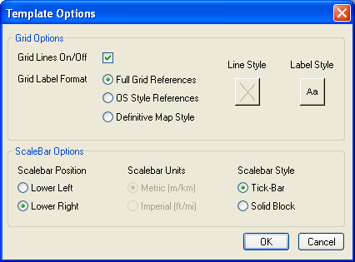

If you need any help, please contact a member of the corporate GIS team.

